MYSQL TASK

CRETAE A TABLE EMPL  
  
CREATE TABLE Empl ( empno INTEGER PRIMARY KEY, ename TEXT NOT NULL, job TEXT NOT NULL, mgr INTEGER, hiredate DATE, sal float, comm float, depyno INTEGER);

INSERT QUERY

INSERT INTO Empl VALUES (8369, 'SMITH', 'CLERK',8902, "1990-12-18", 800.00, NULL, 20);

INSERT INTO Empl VALUES (8499, 'ANYA', 'SALESMAN', 8698, "1991-02-20", 1600.00, 300.00, 30);

INSERT INTO Empl VALUES (8521, 'SETH', 'SALESMAN', 8696, "1991-02-22", 1250.00, 500.00, 30);

INSERT INTO Empl VALUES (8566, 'MAHADEVAN', 'MANAGER', 8839, "1991-04-02", 2985.00, NULL, 20);

INSERT INTO Empl VALUES (8654, 'MOMIN', 'SALESMAN', 8698, "1991-09-28", 1250.00, 1400.00, 30);

INSERT INTO Empl VALUES (8698, 'BINA', 'MANAGER', 8839, "1991-05-01", 2850.00, NULL, 30);

INSERT INTO Empl VALUES (8882, 'SHIVANSH', 'MANAGER', 8839, "1991-06-09", 2450.00, NULL, 10);

INSERT INTO Empl VALUES (8888, 'SCOTT', 'ANALYST', 8566, "1992-12-09", 3000.00, NULL, 20);

INSERT INTO Empl VALUES (8839, 'AMR', 'PRESIDENT', NULL, "1991-11-18", 5000.00, NULL, 10);

INSERT INTO Empl VALUES (8844, 'KULDEEP', 'SALESMAN', 8696, "1991-09-06", 1500.00, 0.00, 30);

1. **Write a query to display Ename and sal of employees whose salary are greater than or equal to 2200?**

SELECT ename, sal FROM Empl where sal >= 2200.00;

OUTPUT:

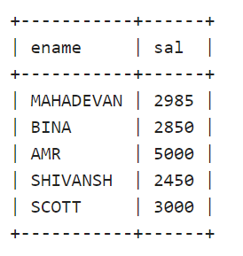

1. **Write a query to display details of employees who are not getting commission?**

SELECT * FROM Empl where comm IS NULL;

OUTPUT:

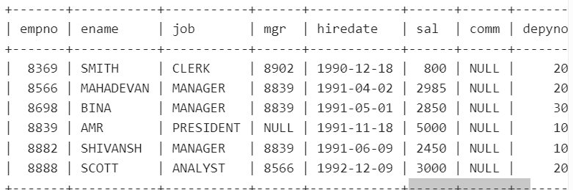

1. **Write a query to display employee name and salary in the range of 2500 to 4000?**

SELECT ename, sal FROM Empl where sal >= 2500.00 and sal <= 4000.00;

OUTPUT:

1. **Write a query to display the name, job title and salary of employees who don’t have a manager?**

SELECT ename, job, sal FROM Empl where mgr IS NULL;

OUTPUT:

1. **Write a query to display the name of an employee whose name starts with “A” as alphabet?**

SELECT ename FROM Empl where ename like 'A%';

OUTPUT:

SELECT ename FROM Empl where ename like '__A%';

OUTPUT:

Empty result.

1. **Write a query to display the name of an employee whose name contains “T” as the last alphabet?**

SELECT ename FROM Empl where ename like '%T';

OUTPUT:

